Fall Quarterly Exam in AP Calculus AB



AP Calculus AB

Friday, October 30, 2015

Section II – Part B (60 Minutes)

No Calculators Allowed

Student Name: _____________________________________________________________

Teacher: ________________________________________________________________________

SECTION II – PART A DIRECTIONS

**60 Minutes: 4 Open Response** *(9 points each)*

Solve each of the following problems, showing ALL work. Your work will be scored on the correctness and completeness of your methods as well as your answers. Unless otherwise specified, answers (numeric or algebraic) need not be simplified. You may not use a calculator during this section. **ALL work must be completed in pencil.**

1. **The twice–differentiable function *f* is defined for all real numbers and satisfies the conditions:**

**.**

1. **The function *g* is given by  for all real numbers, where *a* is a constant. Find  and  in terms of *a*. Show the work that leads to your answers.**
2. **The function *h* is given by  for all real numbers, where *k* is a constant. Find  and write an equation for the line tangent to the graph of *h* at** **.**

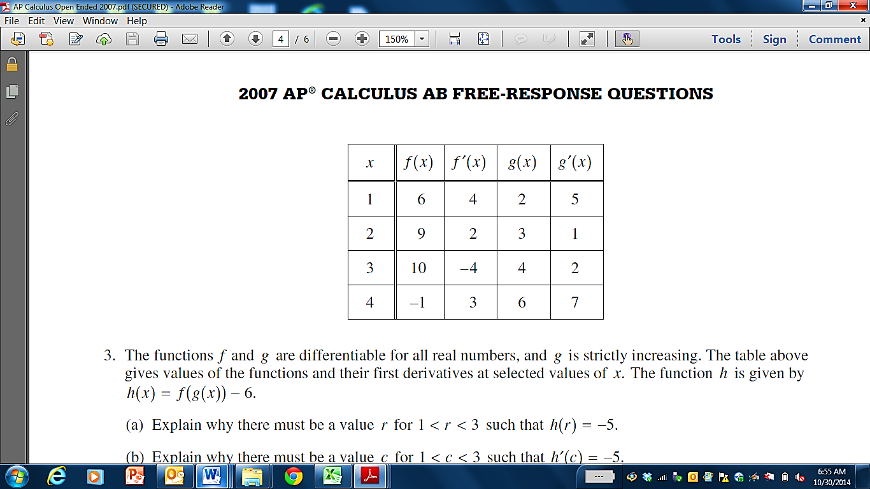

1. **The functions *f* and *g* are differentiable for all real numbers, and *g* is strictly increasing. The table above gives values of the functions and their first derivatives at selected values of *x*.**
2. **Let . Find .**
3. **Let . Find .**



1. **The functions *f* and *g* are differentiable for all real numbers, and *g* is strictly increasing. The table above gives values of the functions and their first derivatives at selected values of *x*.**
2. **If , determine whether  is increasing or decreasing at . Justify your answer.**

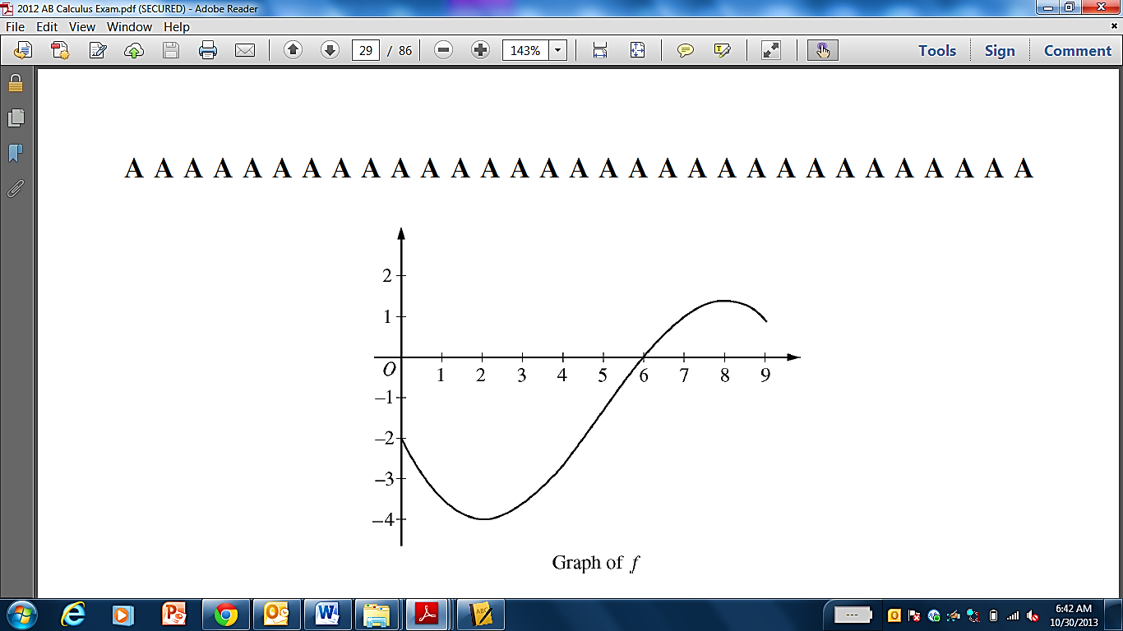

1. **Let *f* be a function defined on the closed interval  with . The graph of , the derivative of *f*, is shown above.**
2. **For , find all values of *x* at which *f* has a relative minimum. Justify your answer.**
3. **For , find all values of *x* at which the graph of *f* has a point of inflection. Justify y our answer.**
4. **Find all intervals on which the graph of *f* is both decreasing and concave up. Justify your answer.**
5. **Let *h* be defined as . Find the equation of the line tangent to  at .**
6. **Let *f* be a differentiable function for which  and whose derivative is given by the equation  for all .**
7. **Find the *x*–coordinate of the critical point of *f*. Determine whether this point is a relative minimum, a relative maximum, or neither for the function *f*.**
8. **The graph of the function *f* has exactly one point of inflection. Find the *x*–coordinate of this point.**
9. **Find all intervals for which the graph of *f* is both increasing and concave up. Justify your answer.**
10. **Find the equation of the line tangent to *f* at .**

**END OF EXAM**